**Plans and Progress**

**The Plan**

This project was originally an idea for simple collection catalogue where a user could store information on collectables they own. It would consist of two lists, one that would contain the catalogue of items and one that would contain the items the user would like to trade. These two lists would be handy as they would allow the user to search for a particular item, such as a trading card without having to sift through their entire collection to see if they own it. This Idea in alone would be a great product and very simple to design.

After a number of discussions with the team in regards to the possibility of creating other features to expand on the idea of the product, the team decided to make the simple collectible catalogue more of a social media platform where collectors could view other users collectables, see what they are willing to trade and organize the trading of items.  
The program would also feature a news feed containing information posted by contacts, a market place where you could post items to trade, a calendar with information about upcoming events such as Comicon or Armageddon, a database of products from the likes of Pokemon, yugi-oh and magic the gathering, and finally a video chat player versus player platform where users could have card battles online.

Of course this was a lot to do in a small amount of time. So the team decided on a simple user interface with a database, the catalogue and trade lists and the news feed.

**The Program Design**

With a solid idea of what the basic program needed, the team began designing the program. The program and interface would be written using Java, and the database would use SQL. As mentioned earlier, the basic layout of the main application would be a user interface consisting of two lists using JList from Java swing class, one list for the users collection catalogue and the other containing all of the items the user desires to trade. Each list will have a text field also from the swing class. The text field on the collection side would be used to add to and search for items in the collection list. The text field on the trade side would be used for the soul purpose of searching for items in the trade list. Items would be loaded from the collection list to the trade list by selecting the item then pressing the trade button on the trade side of the interface. The final feature of the basic lay out would be a delete button above each list that would allow the user to remove items from the lists if the item had been sold, traded, or simply lost.

*CollectStra app Basic layout before GUI design added*

Next would be to create the news feed. This section of the project turned out to be a bigger task than we had hoped, unfortunately due to time constraints the team had to focus on tasks that were more important to the completion of the project and we did not have enough time to get the news feed off the ground. The team did manage to create a simple example to ad to the prototype. The base news feed updates whenever a user trades an item letting the users connections see what is being traded. This will be a great feature as it will give users the ability to see what is for trade and stream line the process by allowing users to organize the trade over the application.

Though this feature is only in the early stages of development in the future the team will complete this feature and add it to the finished product making trading items a lot simpler. Here is an example of what the news feed will look like once it is completed. As you can see the news feed has similar look to Facebook or Instagram. The team at TextraOne believe this is the best way to present the app to users as most will already be familiar with operating Facebook. TextraOne would like to make this application as user friendly as possible.

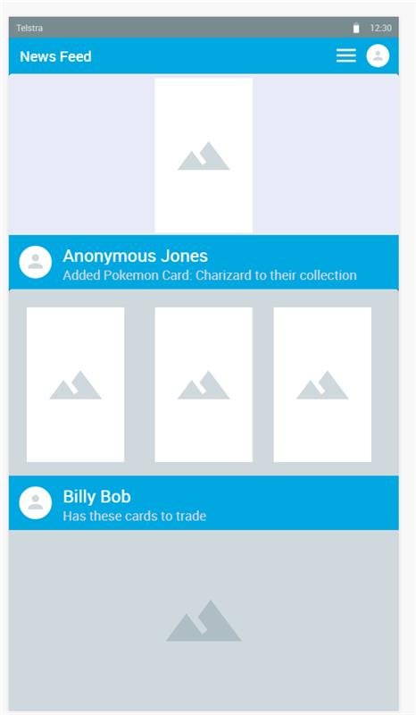  
*Sample GUI of news feed designed by Tim Hall*

Next we will discuss the database of items from brands such as Pokemon and Magic. One of the great features of the application will be the database containing all of the collectables that have been released by brands such as magic and Pokemon. At the touch of a button you could see the title, picture, rarity and the stats of any trading card in a collection. This would give the user the ability to see what card they would like to acquire, what cards are available and cards that would work best with their personal battle style. This will be an invaluable tool for any die-hard Trader.

The database of course would grow and become more refined in later updates. There would to be legal assessments and talks with the big name brands to acquire permission to access there database and syphon the information to the CollectStra application database. How ever this is an issue that will be addressed once the application is closer to completion. Once again, this feature proved more difficult than the team had hoped and as a result it was not completed in time to be implemented into the assignment. Later in the report you will details about the implementation of the database the use of SQL and JDBC driver, as well the methods that will be used to complete this feature.

The Graphical User Interface, or GUI for short, is one of the most vital parts of the application. This is the first pint of contact for all users. With that in mind, the team at TextraOne wanted to make sure it was as user friendly as possible. Many social media users are more that a little bit familiar with operating websites and applications like Facebook and Instagram. There for the team decided to design the user interface in a way that would look and work similar to these social media platforms.

As mentioned earlier, the news feed would resemble that of Facebook. The user can scroll through updates and posts from other users that they are acquainted with, chat to other users and organize trades. There will also be a calendar and event pages where users can learn about up coming events. The user interface was designed through Fluid UI, a web service that provided all the tools needed to create the ideal graphical user interface for CollectStra. The user interface is currently still in development, there for the team was unable to add it to the program.

In conclusion, the team at TextraOne have the blueprint’s of a great trading program. There are many features in development that will help make CollectStra the number one application for traders world wide. Though it is unfortunate that the team could not produce the complete program, we did manage to create a working prototype that includes the basic features such as the Collection and Trade page, and a basic model of the news feed. This prototype will be featured in the video presentation and may be available upon request.